Effective Coaching of Teachers: Completed Sample of the Fidelity Tool Worksheet

Purpose of the Fidelity Tool
Like any other educational innovation, the coaching of teachers must be used with fidelity in order to achieve its intended outcomes. Although fidelity is often thought of as adherence to the “key ingredients” of the innovation, it also includes aspects such as quality, responsiveness of the participants (e.g., coach responsiveness to teacher needs), and dose.
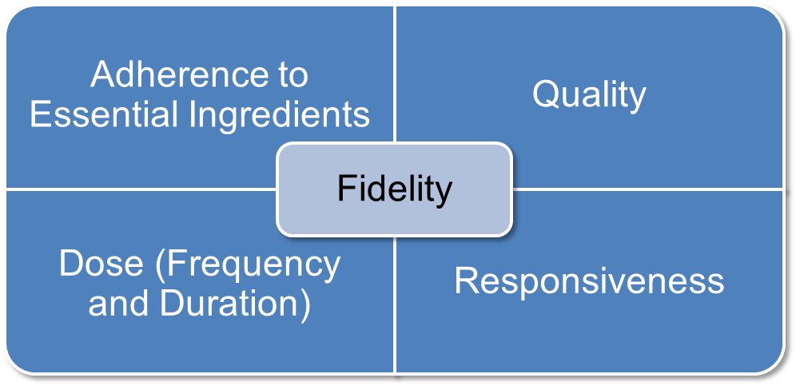
This means that fidelity in coaching should continuously adhere to the effective practices of observation, modeling, delivery of performance feedback, and use of alliance-building strategies. Furthermore, coaching should occur with sufficient frequency and duration, ensure that teachers are engaged with the coaching session such that their needs are being met, and be of high quality.
This document serves as an example of how an observer can complete the Fidelity Tool Worksheet. It is intended to be used in conjunction with several other tools:
- Effective Practices for Coaches. The module summarizes effective coaching practices.
- Measuring the Fidelity of Coaching. The module provides a summary of why fidelity data on coaching are important. The module also describes the process for collecting and using coaching fidelity data.
- Effective Coaching of Teachers: Fidelity Tool Rubric. This rubric offers information and guidelines for how to measure the fidelity of coaching using the Fidelity Tool Worksheet.
- Effective Coaching of Teachers: Fidelity Tool Worksheet. The worksheet can be used to record coaching fidelity data.
- Effective Coaching: Improving Teacher Practice and Outcomes for All Learners. This brief, and the accompanying infographic Effective Coaching Practices, synthesizes research on coaching and offers a framework of effective coaching practices that should be central to the everyday work of coaches.
- Implementation Guide for Effective Teacher Coaching. The purpose of this guide is to help practitioners systematically implement effective coaching practices. If coaching is designed to improve teaching practice and learning outcomes, it is important to examine how it is implemented.

Table 1. Before Observation of the Coaching Session (to be completed by observer and coach)
Coach Name:  Manuel | Observer Name:  Samia
Date:  September 29, 2016 | Time of Observation:  10:00–10:30 a.m.
Brief Description of Coaching Session (What will occur during the coaching session with the teacher?)
Background: Manuel has been coaching Theresa on her reading instruction in her third-grade classroom. Manuel stated that Theresa recently asked Manuel to help her use graphic organizers with her students to increase their comprehension of nonfiction text. She also asked Manuel for support in the area of classroom management, with a particular concern about student engagement among struggling learners and overall classroom climate.
I (Samia) observed Manuel on September 29, 2016, while he coached Theresa. Manuel:
- Observed Theresa as she taught a whole-group reading lesson that required students to use a graphic organizer to identify main ideas and details.
- Modeled the use of a graphic organizer while Theresa watched him teach.
- Continued his observation of Theresa as she resumed teaching her students.
- Collected data about student engagement, praise, and redirections.
- Left a short note for Theresa on her desk that read: “After I modeled the use of graphic organizers, you immediately began to teach students how to use the graphic organizer to categorize main ideas and details. During this time, 27 of the 30 students were engaged in the lesson. Throughout the lesson you redirected one student five times and praised all students 10 times. Great work implementing graphic organizers after the demonstration, engaging most students, and using praise to create a positive environment. Let’s reconnect after school to further discuss the lesson and learning outcomes among students.
I then observed Manuel conduct a postconference debrief with Theresa. Manuel:
- Provided additional performance feedback, with a focus on clarifying which students were not engaged during the lesson and helping Theresa identify how to engage struggling learners.
- Used alliance strategies, including asking open-ended questions and clarifying Theresa’s teaching goal.
- Established the next date and time of coaching.
Goal(s) of Coaching Session (What does the coach hope to achieve with the teacher and learners as a result of the coaching session?) Although Manuel has conducted several coaching cycles with Theresa, Theresa was not certain how to introduce graphic organizers to her students—particularly students with academic and behavioral challenges. Manuel’s goal for coaching Theresa was to help her accurately use graphic organizers to increase students’ comprehension of nonfiction text.

Table 2. During Observation of the Coaching Session (to be completed by observer)
Coaching Practice | Adherence | Quality | Dose | Responsiveness
Observation: Watching the teacher in the classroom environment use a specific program, intervention, or practice | - No (0 points)  Yes (1 point) | - 0 points  - 1 point  2points | 1 2 3  Additional Information:  Number of minutes coach observes teacher:__________  Number of times coach reports observing a teacher per month:___________ | 1 2 3
Modeling (also referred to as demonstration): Showing the teacher how to use a specific program, intervention, or practice when the teacher is unfamiliar with the practice or uses it incorrectly | - Not applicable (N/A): modeling was not needed  - No (0 points)  Yes (1 point) | - Not applicable (N/A): modeling was not needed  - 0 points  - 1 point  2 points | 1 2 3  OR: N/A  Additional Information:  Number of opportunities where modeling should have occurred but did not:  _________________ | 1 2 3  OR: N/A
Performance Feedback: Presenting formal or informal data about the teacher’s use of a specific program, intervention, or practice | - No (0 points)  Yes (1 point) | Check all that apply to the session (1 point per checked box):  - Based on the teacher’s practice (e.g., an EBP, a classroom management practice)  Specific  Positive  Corrective (if warranted), or corrective was not warranted  Timely (within 1–2 days)  Additional Information:  How was feedback provided? (e.g., verbal, anecdotal note, graphical)  _________________  When was it provided? (e.g., during preobservation, postobservation conference, and/or in the moment of teaching)  _________________ | 1 2 3  Additional Information:  Number of performance feedback statements made by coach to teacher:  Positive statements:  _________________  Corrective statements:  _________________ | 1 2 3
Alliance-Building Strategies: Using specific strategies that relate to factors of alliance to build a positive relationship in a teacher–coach dyad (factors of alliance include effective interpersonal skills, collaboration, and expertise) | - No (0 points)  Yes (1 point) | Check all that apply to the session (1 point per checked box):  - Restating and summarizing information conveyed by the teacher  Asking open-ended questions  - Affirming difficulty of change  - Using nonevaluative language  - Referring to past accomplishments  Identifying and working toward the teacher’s goals and needs  - Conveying that improved teaching is about teamwork  - Conveying expertise in teaching and deep content knowledge  - Explaining complex concept succinctly | 1 2 3 | 1 2 3
USE THIS FORM TO CALCULCATE FIDELITY OF COACHING PRACTICE IF COACH MODELED DURING THE COACHING CYCLE OR IF MODELING WAS NEEDED BUT DID NOT OCCUR | Points Possible for Column: 4  Points: 4  ________________ | Points Possible for Column: 18  Points: 10  _______________ | Points Possible for Column: 12  Points: 11  _______________ | Points Possible for Column: 12  Points: 11  _______________
Total Points Earned: 36
Total Points Possible: 46
Calculation: Total Points Earned/Total Points Possible × 100 = Percentage of Fidelity of Coaching Practice
78% Fidelity of Coaching Practice
Comments/Notes:

Table 3. After Observation of the Coaching Session (to be completed by observer and coach)
Discussion Prompts for Coach and Observer
Examples:
- How did the coaching session go? Manuel views the coaching session with Theresa as productive and informative because she improved her use of graphic organizers.
- What did we learn about coaching? What fidelity data support our conclusions? Manuel learned that he could increase his use of alliance-building strategies (e.g., affirming the difficulty of change and referring to Theresa’s past teaching accomplishments). Manuel thinks that using these strategies will allow him to gradually guide Theresa toward a new area: increasing her instructional pacing. Increasing her pacing also may help her to engage students with learning and behavioral challenges.
- To what degree did coaching achieve its intended goal? Manuel did achieve his immediate goal of supporting Theresa in her use of graphic organizers and in classroom management. Some struggling learners were not engaged during instruction, however, and Manuel will continue to work with Theresa in this area.
- How did coaching achieve its intended goal? In other words, what did the coach do that was most/least effective? Theresa responded positively to written feedback about her teaching (e.g., student engagement, praise, and redirections). Manuel plans to continue to use written feedback with Theresa. Theresa also responded positively to alliance strategies.
- How will this information be used to support, rather than evaluate, coaches? Samia and Manuel will use information from this tool to continually improve his coaching practice, the impact of his coaching on teaching and learning, and how his coaching will evolve over time.
Next Steps (What is a future coaching goal? What do we need to do as follow-up, and by when?) Samia and Manuel will reconvene in a month.
Date for Future Observations: October
Comments/Notes:
Manuel was concerned at first that fidelity data would be used to formally evaluate him. Once we established that the data is used to support him, he voiced an interest in continuing with this process.
Manuel is coaching several teachers in reading, math, and classroom management. He would like for Samia to observe him working with other teachers to determine whether he consistently uses effective coaching practices with all teachers.

Contributors to Effective Coaching of Teachers: Completed Sample of the Fidelity Tool Worksheet
Suggested citation: Pierce, J. D. (2018). Effective coaching of teachers: Completed sample of fidelity tool worksheet. San Francisco, CA: WestEd.
For additional information regarding content, please contact Ask the NCSI at https://ncsi.wested.org/ask-the-ncsi/. Ask the NCSI is a research and information service provided by the National Center for Systemic Improvement (NCSI). Ask the NCSI is intended to support states to (1) obtain information about evidence-based practices; (2) develop, implement, and evaluate State Systemic Improvement Plans (SSIPs); (3) learn about practices being implemented in other states; and (4) find out what current research says about “what works” to improve results for children with disabilities.
Ask the NCSI will accept information requests from NCSI clients; e.g., state departments of education (Part B) and state lead agencies for the early intervention program (Part C of the IDEA). Our goal will be to provide a response to your request within 5-21 days. For specific technical assistance (TA) requests, states are invited to contact their assigned TA Facilitators.
You may contact NCSI at NCSI@wested.org or 866.664.8471.
We look forward to hearing from you!
The contents of this document were developed under a grant from the US Department of Education, #H326R140006. However, those contents do not necessarily represent the policy of the US Department of Education, and you should not assume endorsement by the Federal Government. Project Officers: Perry Williams and Shedeh Hajghassemail (November 2014).

Where we use the word teacher throughout this document, we include individuals, such as early child care providers, interventionists, and parents, who work with learners in a less traditional educational setting (often the learner’s home), in addition to the individuals, such as prekindergarten through grade 12 teachers, who work with learners in a classroom setting. We use learner to refer to the infants, toddlers, children, and youth with whom these broadly defined teachers work.

