# Effective Coaching of Teachers: Fidelity Tool Worksheet

## Purpose of the Fidelity Tool

Like any other educational innovation, the coaching of teachers[1] must be used with fidelity in order to achieve its intended outcomes. Although fidelity is often thought of as adherence to the “key ingredients” of the innovation, it also includes aspects such as quality, responsiveness of the participants (e.g., coach responsiveness to teacher needs), and dose.

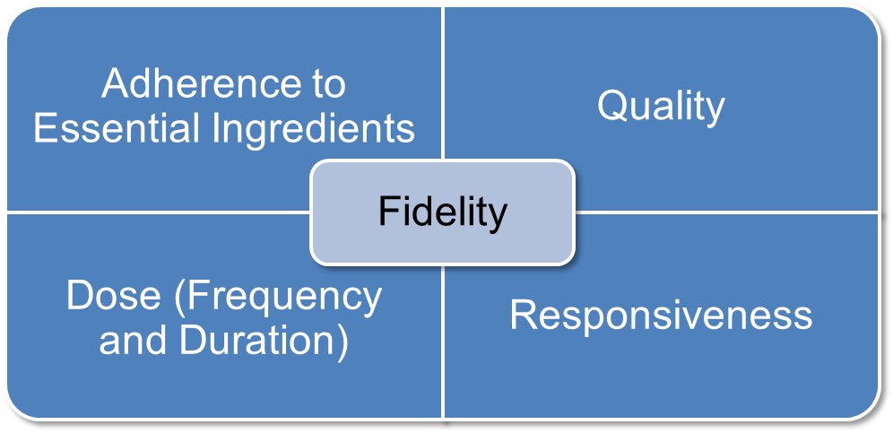

This means that fidelity in coaching should continuously adhere to the effective practices of observation, modeling, delivery of performance feedback, and use of alliance-building strategies. Furthermore, coaching should occur with sufficient frequency and duration, ensure that teachers are engaged with the coaching session such that their needs are being met, and be of high quality.

This tool can be used to help measure the fidelity of coaching so that these data can be used by coaches and other educators to continuously improve upon how coaching occurs. However, this tool should *not* be used to formally evaluate coaching practice or used in a manner that is not supportive of educators serving in the role of coach. In addition, this tool is intended to be used in conjunction with several other resources:

* *[Effective Practices for Coaches](http://airhsdlearning.airws.org/ncsi-effectivecoaching/11-15/story_flash.html)*. The module summarizes effective coaching practices.
* Measuring the Fidelity of Coaching. The module provides a summary of why fidelity data on coaching are important. The module also describes the process for collecting and using coaching fidelity data.
* [*Effective Coaching of Teachers: Fidelity Tool Rubric*](https://ncsi-library.wested.org/system/resources/documents/000/000/059/original/NCSI_Coaching-Fidelity-Tool_Rubric-508_1_.pdf?1490204815). This rubric offers information and guidelines for how to measure the fidelity of coaching. Refer to the rubric when completing this worksheet.
* *[Effective Coaching of Teachers: Completed Sample of Fidelity Tool Worksheet](https://ncsi-library.wested.org/system/resources/documents/000/000/189/original/NCSI_Coaching-Fidelity-Tool_Worksheet_completed-sample-508_%282%29.pdf?1497294973).* This sample provides an example of how the fidelity tool worksheet may be completed and used.
* [*Effective Coaching: Improving Teacher Practice and Outcomes for All Learners*](https://ncsi-library.wested.org/system/resources/documents/000/000/057/original/NCSI_Effective-Coaching-Brief-508_1_.pdf?1490127749). This brief, and the accompanying infographic [*Effective Coaching Practices*](https://ncsi-library.wested.org/system/resources/documents/000/000/188/original/NCSI_Coaching_Infographic5.pdf?1497294857), synthesizes research on coaching and offers a framework of effective coaching practices that should be central to the everyday work of coaches.
* [*Implementation Guide for Effective Teacher Coaching*](https://ncsi-library.wested.org/system/resources/documents/000/000/060/original/NCSI_Teacher_Coaching_Implementation_Guide-508_1_.pdf?1490204994). The purpose of this guide is to help practitioners systematically implement effective coaching practices. If coaching is designed to improve teaching practice and learning outcomes, it is important to examine how it is implemented.

## Directions for Use

1. Identify roles:
2. The observer: The person who will meet with the coach, watch the coach, and score coaching practice.
3. The coach: The person who coaches teachers.
4. The teacher: The person coached by the coach.
5. Gather the materials listed below and ensure that the observer and coach are familiar with the following:
6. The four effective coaching practices as described in the infographic, [*Effective Coaching Practices*](https://ncsi-library.wested.org/system/resources/documents/000/000/188/original/NCSI_Coaching_Infographic5.pdf?1497294857), research brief, [*Effective Coaching: Improving Teacher Practice and Outcomes for All Learners*](https://ncsi-library.wested.org/system/resources/documents/000/000/057/original/NCSI_Effective-Coaching-Brief-508_1_.pdf?1490127749)*,* and the online module, [*Effective Practices for Coaches*](http://airhsdlearning.airws.org/ncsi-effectivecoaching/11-15/story_flash.html).
7. The overall process of collecting and sharing coaching fidelity data, as described within this worksheet,and more extensively in the online module, Measuring the Fidelity of Coaching. Pay particular attention to Tables 1–3 within the worksheet, which will be completed by the observer.
8. The rubric contained within [*Effective Coaching of Teachers: Fidelity Tool Rubric*](https://ncsi-library.wested.org/system/resources/documents/000/000/059/original/NCSI_Coaching-Fidelity-Tool_Rubric-508_1_.pdf?1490204815).
9. The companion tool, [*Effective Coaching of Teachers: Completed Sample of Fidelity Tool Worksheet*](https://ncsi-library.wested.org/system/resources/documents/000/000/189/original/NCSI_Coaching-Fidelity-Tool_Worksheet_completed-sample-508_%282%29.pdf?1497294973), which shows how one observer used the worksheet to collect fidelity data on coaching.
10. Conduct observer–coach meetings, collect fidelity data on coaching, and calculate the final score:
    * The observer meets with the coach and completes Table 1, “Before Observation of the Coaching Session” (page 4 of this document).
    * The observer conducts an observation of the coach and completes Table 2, “During Observation of the Coaching Session” (pages 5–9 of this document), referring to the rubric as needed to determine the most appropriate score. Adherence and quality are scored by checking boxes. Dose and responsiveness are scored on a scale of 1 to 3, where 1 is the low score and 3 is the high score.
    * The observer calculates the percentage of coaching fidelity. If modeling occurred, or if modeling was needed but did not occur, calculate the fidelity of coaching practice on page 8. If modeling ***was* *not needed*** during the session, check the box marked “N/A” on page 5 (and circle “N/A” in each cell of that row). Calculate the fidelity of coaching practice on page 9.

* The observer conducts a coach-and-observer meeting and completes Table 3, “After Observation of the Coaching Session” (page 10).

1. Repeat step 3, revisiting other NCSI coaching resources as needed. **Table 1. Before Observation of the Coaching Session *(to be completed by observer and coach)***

|  |  |
| --- | --- |
| **Coach Name:** | **Observer Name:** |
| **Date:** | **Time of Observation:** |
| **Brief Description of Coaching Session** *(What will occur during the coaching session with the teacher?)* | |
| **Goal(s) of Coaching Session** *(What does the coach hope to achieve with the teacher and learners as a result of the coaching session?)* | |

Table 2. During Observation of the Coaching Session *(to be completed by observer)*

| **Coaching Practice** | **Adherence** | **Quality** | **Dose** | **Responsiveness** |
| --- | --- | --- | --- | --- |
| **Observation:** Watching the teacher in the classroom environment use a specific program, intervention, or practice | * No (0 points) * Yes (1 point) | * 0 points * 1 point * 2 points | 1 2 3  *Additional Information:*  Number of minutes coach observes teacher:__________  Number of times coach reports observing a teacher per month:*___________* | 1 2 3 |
| **Modeling (also referred to as demonstration):** Showing the teacher how to use a specific program, intervention, or practice when the teacher is unfamiliar with the practice or uses it incorrectly | * Not applicable (N/A): modeling was not needed * No (0 points) * Yes (1 point) | * Not applicable (N/A): modeling was not needed * 0 points * 1 point * 2 points | 1 2 3  OR: N/A  *Additional Information:*  Number of opportunities where modeling should have occurred but did not:  *_________________* | 1 2 3  OR: N/A |
| **Performance Feedback:** Presenting formal or informal data about the teacher’s use of a specific program, intervention, or practice | * No (0 points) * Yes (1 point) | Check all that apply to the session (1 point per checked box):   * Based on the teacher’s practice (e.g., an EBP, a classroom management practice) * Specific * Positive * Corrective (if warranted), or corrective was not warranted * Timely (within  1–2 days)   *Additional Information:*  How was feedback provided? (e.g., verbal, anecdotal note, graphical) _________________  When was it provided? (e.g., during preobservation, postobservation conference, and/or in the moment of teaching)  _________________ | 1 2 3  *Additional Information:*  Number of performance feedback statements made by coach to teacher:  Positive statements:  _________________  Corrective statements:  _________________ | 1 2 3 |
| **Alliance-Building Strategies:** Using specific strategies that relate to factors of alliance to build a positive relationship in a teacher–coach dyad (factors of alliance include effective interpersonal skills, collaboration, and expertise) | * No (0 points) * Yes (1 point) | Check all that apply to the session (1 point per checked box):   * Restating and summarizing information conveyed by the teacher * Asking open-ended questions * Affirming difficulty of change * Using nonevaluative language * Referring to past accomplishments * Identifying and working toward the teacher’s goals and needs * Conveying that improved teaching is about teamwork * Conveying expertise in teaching and deep content knowledge * Explaining complex concept succinctly | 1 2 3 | 1 2 3 |
| **USE THIS FORM TO CALCULCATE FIDELITY OF COACHING PRACTICE IF COACH MODELED DURING THE COACHING CYCLE OR IF MODELING WAS NEEDED BUT DID NOT OCCUR** | **Points Possible for Column: 4**  **Points:**  __________________ | **Points Possible for Column: 18**  **Points:**  _______________ | **Points Possible for Column: 12**  **Points:**  _______________ | **Points Possible for Column: 12**  **Points:**  _______________ |
| **Total Points Earned:** ______________________  **Total Points Possible: 46**  **Calculation:** Total Points Earned/Total Points Possible × 100 = Percentage of Fidelity of Coaching Practice  __________/46 × 100 = __________________% Fidelity of Coaching Practice  ***Example:***  4 + 14 + 10 + 12 = 40; 40/46 × 100 = 87% Fidelity of Coaching Practice | | | |
| **Comments/Notes:** | | | | |
| **USE THIS FORM TO CALCULCATE FIDELITY OF COACHING PRACTICE IF MODELING WAS NOT NEEDED** | **Points Possible for Column: 3**  **Points:**  **__________________** | **Points Possible for Column: 16**  **Points:**  **_______________** | **Points Possible for Column: 9**  **Points:**  **_______________** | **Points Possible for Column: 9**  **Points:**  **_______________** |
| **Total Points Earned: ______________________**  **Total Points Possible: 37**  **Calculation:** Total Points Earned/Total Points Possible × 100 = Percentage of Fidelity of Coaching Practice  __________/37 × 100 = __________________% Fidelity of Coaching Practice  ***Example:***  3 + 10 + 9 + 9 = 31; 31/37 × 100 = 84% Fidelity of Coaching Practice | | | |
| **Comments/Notes:** | | | | |

Table 3. After Observation of the Coaching Session *(to be completed by observer and coach)*

|  |
| --- |
| **Discussion Prompts for Coach and Observer**  Examples:   * How did the coaching session go? * What did we learn about coaching? What fidelity data support our conclusions? * To what degree did coaching achieve its intended goal? * How did coaching achieve its intended goal? In other words, what did the coach do that was most/least effective? * How will this information be used to support, rather than evaluate, coaches? |
| **Next Steps** *(What is a future coaching goal? What do we need to do as follow-up, and by when?)* |
| **Date for Future Observations:** |
| **Comments/Notes:** |

## Contributors to *Effective Coaching of Teachers: Fidelity Tool Worksheet*

Suggested citation: Pierce, J. D., & Ferguson, A. (2018). *Effective coaching of teachers: Fidelity tool worksheet.* San Francisco, CA: WestEd.

For additional information regarding content, please contact *Ask the NCSI* at <https://ncsi.wested.org/ask-the-ncsi/>*. Ask the NCSI* is a research and information service provided by the National Center for Systemic Improvement (NCSI). *Ask the NCSI* is intended to support states to (1) obtain information about evidence-based practices; (2) develop, implement, and evaluate State Systemic Improvement Plans (SSIPs); (3) learn about practices being implemented in other states; and (4) find out what current research says about “what works” to improve results for children with disabilities.

*Ask the NCSI* will accept information requests from NCSI clients; e.g., state departments of education (Part B) and state lead agencies for the early intervention program (Part C of the IDEA). Our goal will be to provide a response to your request within 5-21 days. For specific technical assistance (TA) requests, states are invited to contact their assigned TA Facilitators.

You may contact NCSI at [NCSI@wested.org](mailto:NCSI@wested.org) or 866.664.8471.

We look forward to hearing from you!

The contents of this document were developed under a grant from the US Department of Education, #H326R140006. However, those contents do not necessarily represent the policy of the US Department of Education, and you should not assume endorsement by the Federal Government. Project Officers: Perry Williams and Shedeh Hajghassemail (November 2014).

1. Where we use the word *teacher* throughout this document, we include individuals, such as early child care providers, interventionists, and parents, who work with learners in a less traditional educational setting (often the learner’s home), in addition to the individuals, such as prekindergarten through grade 12 teachers, who work with learners in a classroom setting. We use *learner* to refer to the infants, toddlers, children, and youth with whom these broadly defined *teachers* work.